

**Newsletter**

**Issue 6 Term 2 Week 2**

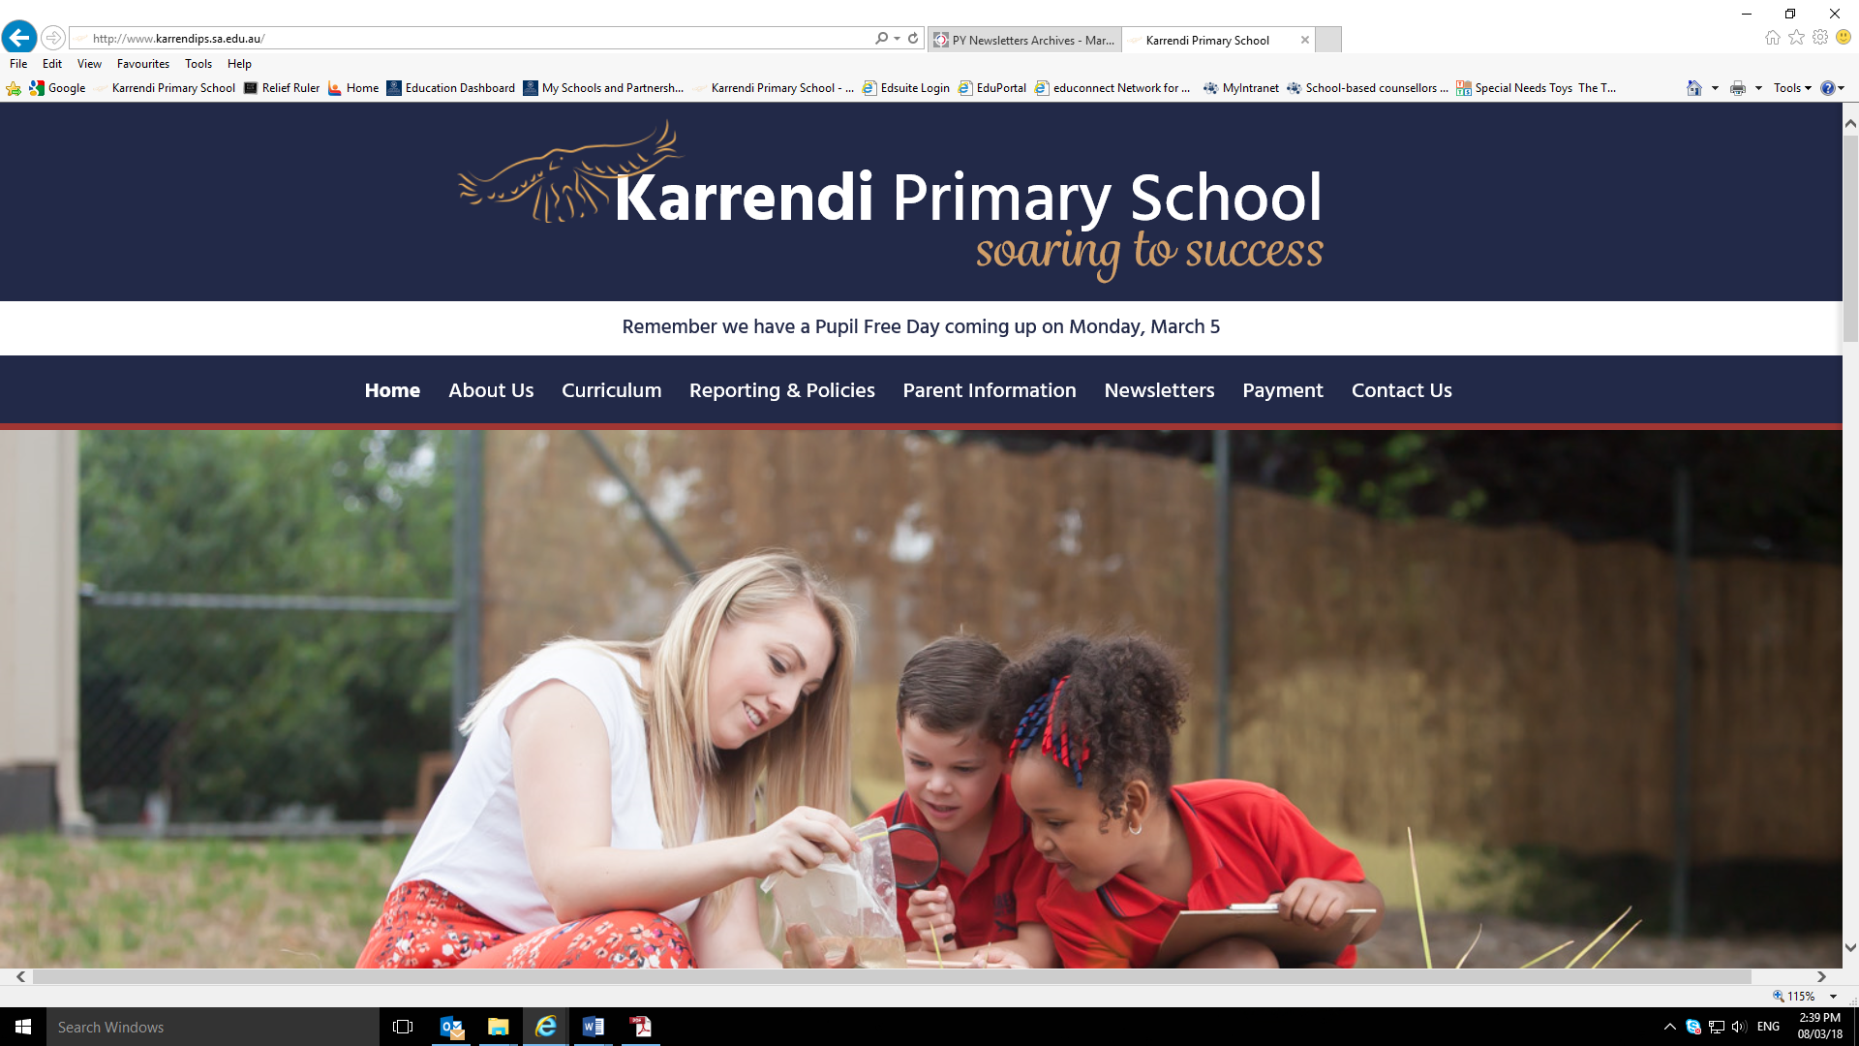

**Diary Dates**

**TERM 2**

**Week 3**

**Mon 13/5**

**Special lunch**

**Tues 14/5-Fri 17/5**

**NAPLAN Testing**

**Thurs 16/5**

**JP Zoo excursion**

**Fri 16/5**

**National Walk Safely to School Day**

**Week 4**

**Mon 20/5-Tues 21/5**

**NAPLaN Testing**

**Wed 22/5**

**Growing With Gratitude**

**Week 5**

**Mon 27/5**

**Pupil Free Day**

**Thurs 30/5**

**Grandparents Day**

**Fri 31/5**

**Girls SAPSASA Soccer**

**Information from the Principal**

Last year we were successful in winning a grant to have a Community Hub located on site at Karrendi Primary School. The Community Hubs program is a National initiative that is jointly funded by Community Hubs Australia and the Department of Social Services. The partner for the Community Hub program in South Australia is Lutheran Community Care.

As outlined in information last year, a hub leader will work in partnership with the Community Hub network, support agencies and school. This work will involve aspects such as linking families with young children to services, support, learning opportunities, building local connections for families in need and delivering formal and informal skills training. Furthermore, The Hub will focus on supporting families to connect to opportunities in the early years, aiming to improve child development and school readiness as well as enhancing settlement outcomes.

We are really pleased to announce that Hayley Wilmer has won the position of Community Hub Leader at Karrendi Primary School. It’s great to have Hayley as part of our staff team! We look forward sharing more news about our Community Hub in the near future.

Regards,



**Information from Hayley – Our Karrendi PS Community Hub Leader**

Thanks to everyone for the warm welcome over the last week. First, I’d like to introduce myself. My name is Hayley Wilmer. I have a Teaching, Youth Support Work and Family Support Work background. I have also had 5 years’ experience running Playgroups. I am a mother of a three year old daughter and I live in the southern suburbs of Adelaide.

I’d like to welcome all families to Karrendi Primary School’s Community Hub. It’s an exciting time for Karrendi! There are currently 7 Hubs around the northern suburbs of Adelaide all offering a range of different programs and activities, including Playgroups and Gardening Programs. Community Hubs are welcoming places where families, especially migrant and refugee families, with young children come to connect, share and learn. In the next week or so I am planning to start a Playgroup on a Thursday morning. In the meantime, if anyone has any preloved toys, art and craft supplies, and kitchen supplies that they would like to donate to the Hub it would greatly be appreciated. There is a plastic box located in the Office for donations.

I can’t wait to get started and am looking forward to hearing all the great ideas families have for Karrendi Primary School Community Hub in 2019!



**Diary Dates**



**Bradman Road, Parafield Gardens SA 5107 Phone 08 82583612 Fax 08 82815851 Email dl.1135.info@schools.sa.edu.au www.karrendips.sa.edu.au**



**Adaptations**

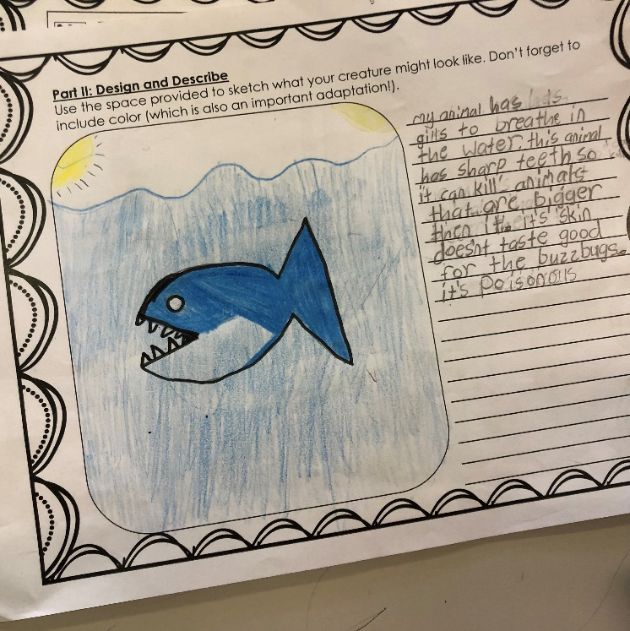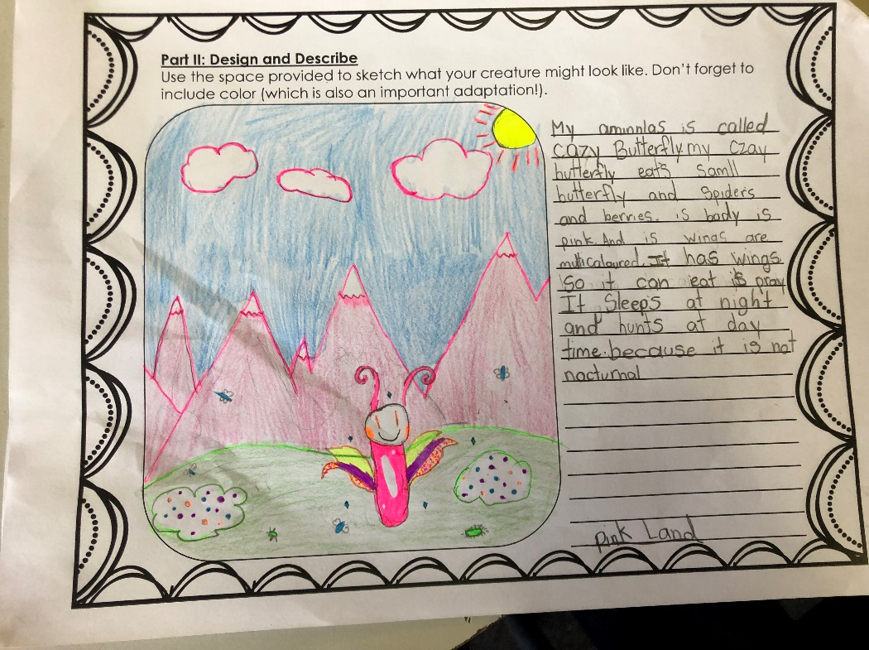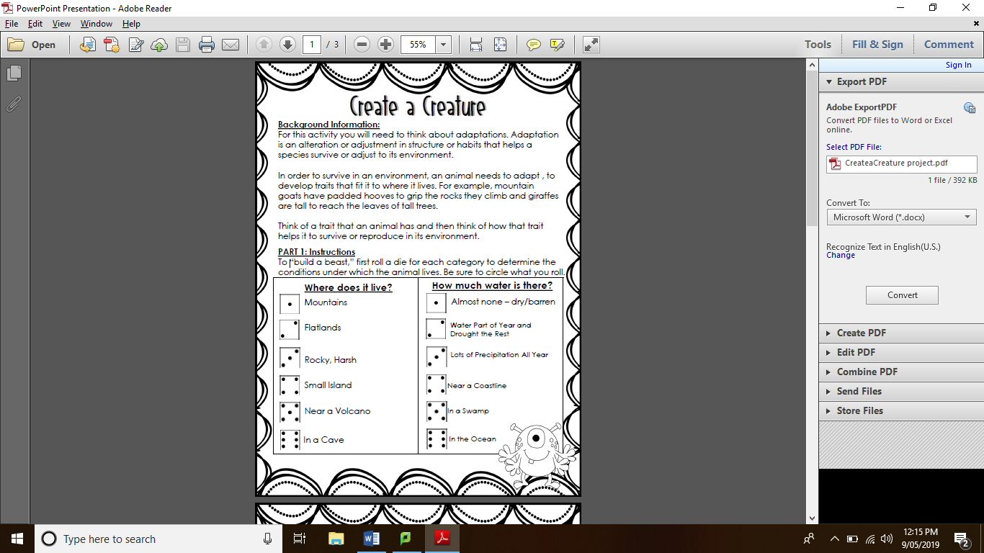

…it’s skin doesn’t taste good for the ‘buzzbugs’ and its poisonous to stop them eating it. Samuel

It has wings so it can catch its prey. It hunts at day time because there are more of the spiders around to eat. Jemma

**In Room 3 this year, we have been learning about adaptations in science. We were given a task where we had to create our own animal that has a set of adaptations for its particular environment. We each rolled a dice to determine the characteristics of the environment in which it lived.**

**Here are some of our animals and their adaptations:**

**In order to survive in an environment, an animal needs to adapt (change), to develop traits that fit it to where it lives.**

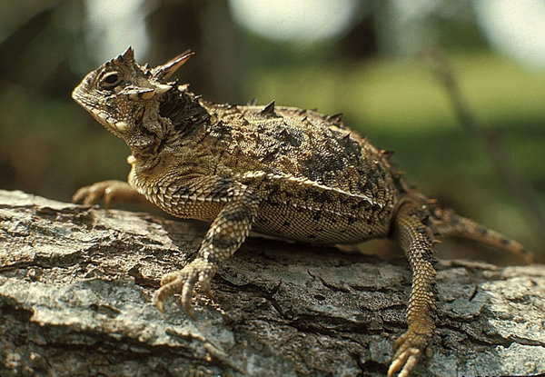

**Amazing adaptation!**

**Texas Horned Lizard**

It can shoot blood out of its eyes to warn off predators!

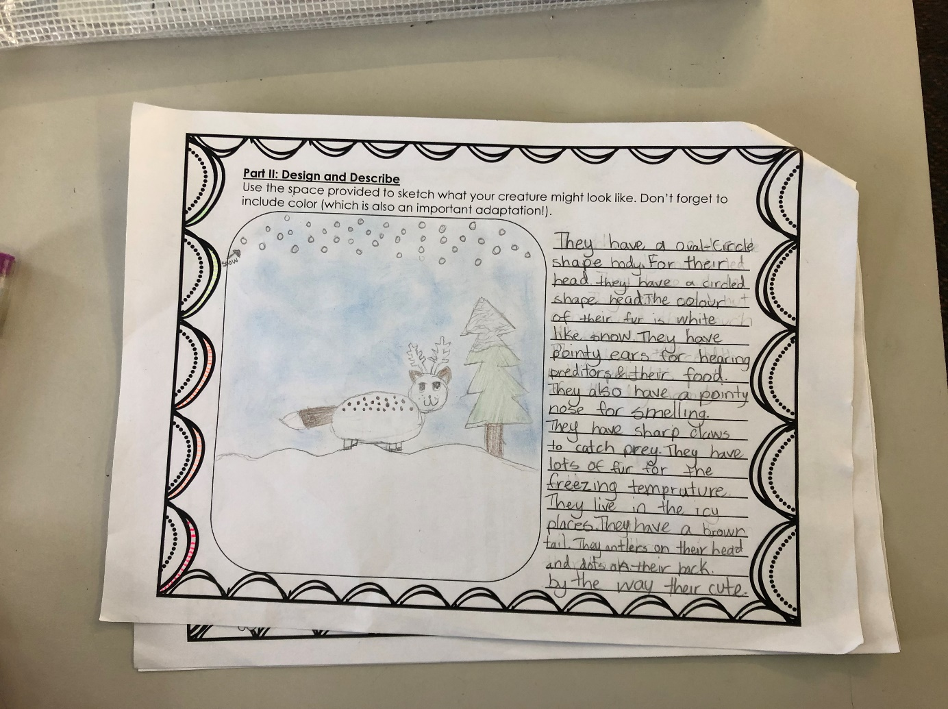

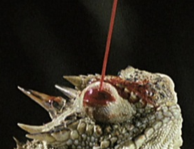

They have lots of fur for the freezing temperatures. Their fur is white, like the snow to help with camouflage. Irene

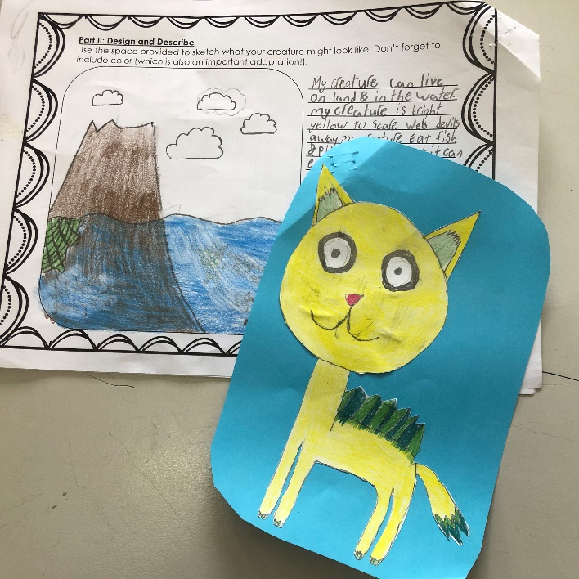

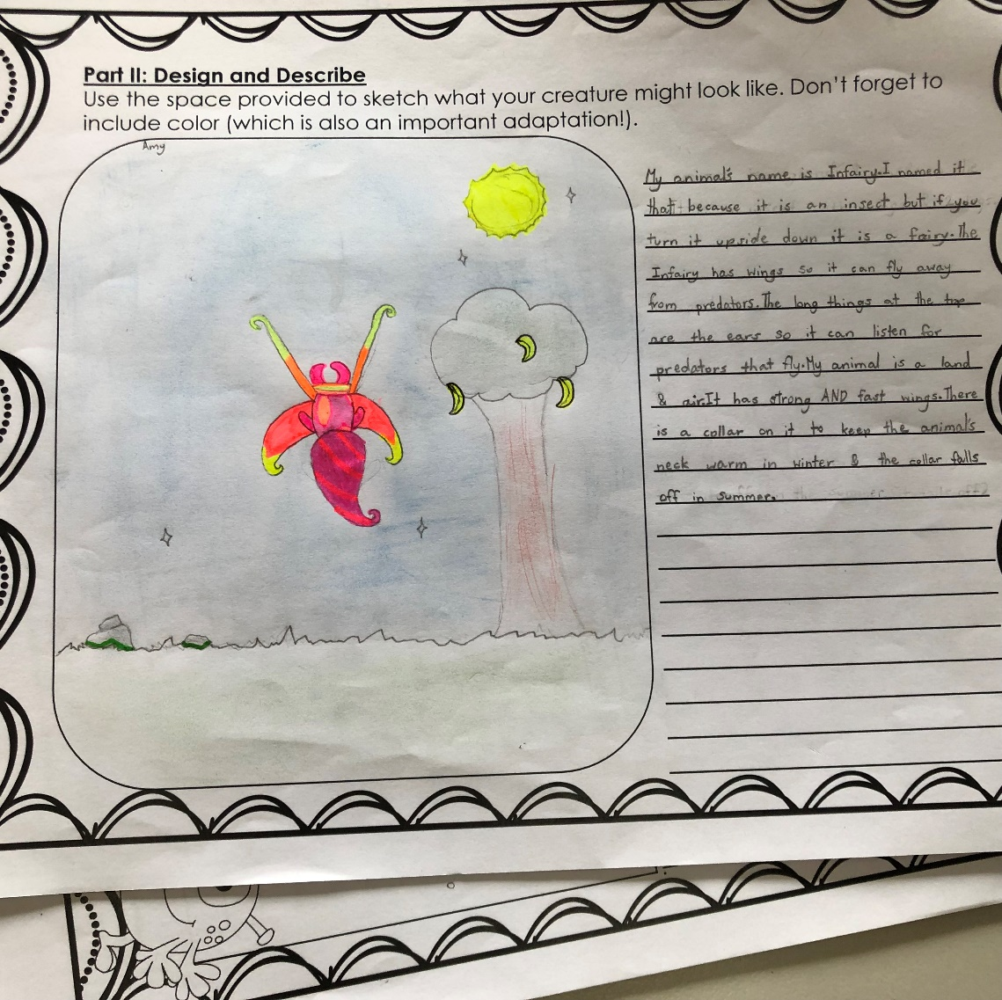

***Page designed and created by   
Ruwayfi and Chirayu***

It has strong and fast wings so it ca fly away from predators. Amy

Students in years 3, 5 and 7 will be participating in our first NAPLAN Online next week. Testing begins on

**Tuesday 14th May** and runs over six days, concluding on **Tuesday 21st May**.

If your child is feeling nervous about NAPLAN, here are some ways you can help them feel more comfortable going into the test:

**Practice Mindfulness**

Encourage your child to meditate, listen to music, even go for a walk together and focus on the nature around you. Taking the time to be mindful goes a long way in reducing stress and anxiety.

**Ease the Pressure**

Let your child know that tests are just one part of school, and that NAPLAN isn’t about passing or failing, or being better than others. It’s just one of the tools used to assess their learning progress.

**Positive Mindset**

Encourage your child to question any negative thoughts and reason with them logically, to believe in themselves and try their best, because that’s all that matters.



